**What to do before returning your British Council laptop**

Once your laptop is returned to the Kuching office, the hard disk will be wiped clean. So, before you hand over your laptop to your PM you should:

1. Take copies of any files that you wish to take with you when you leave.
2. Delete all your files (both personal and professional). This includes documents, music, pictures, videos, etc.
3. Make sure you log out of all programs such as Skype, Messenger, Dropbox, Facebook etc. Better still, you could uninstall these programs using: Control Panel > Programs > Uninstall a program.
4. Clear your internet browser history (see step by step instructions below)

Steps 2 and 3 above are a precaution against the laptop going missing in transit to Kuching.

If you have changed the password on the laptop from the default (ie “password”), please tape the new password to the laptop and put your name on it. We will need this password access the laptop to wipe the hard disk.

How to clear your internet browser history:

**Internet Explorer**

1. The internet explorer history can be cleared by going to the tools icon (the blue cog next to the white star in the top right hand corner of the screen) and selecting the internet options section as indicated below (see red arrow)

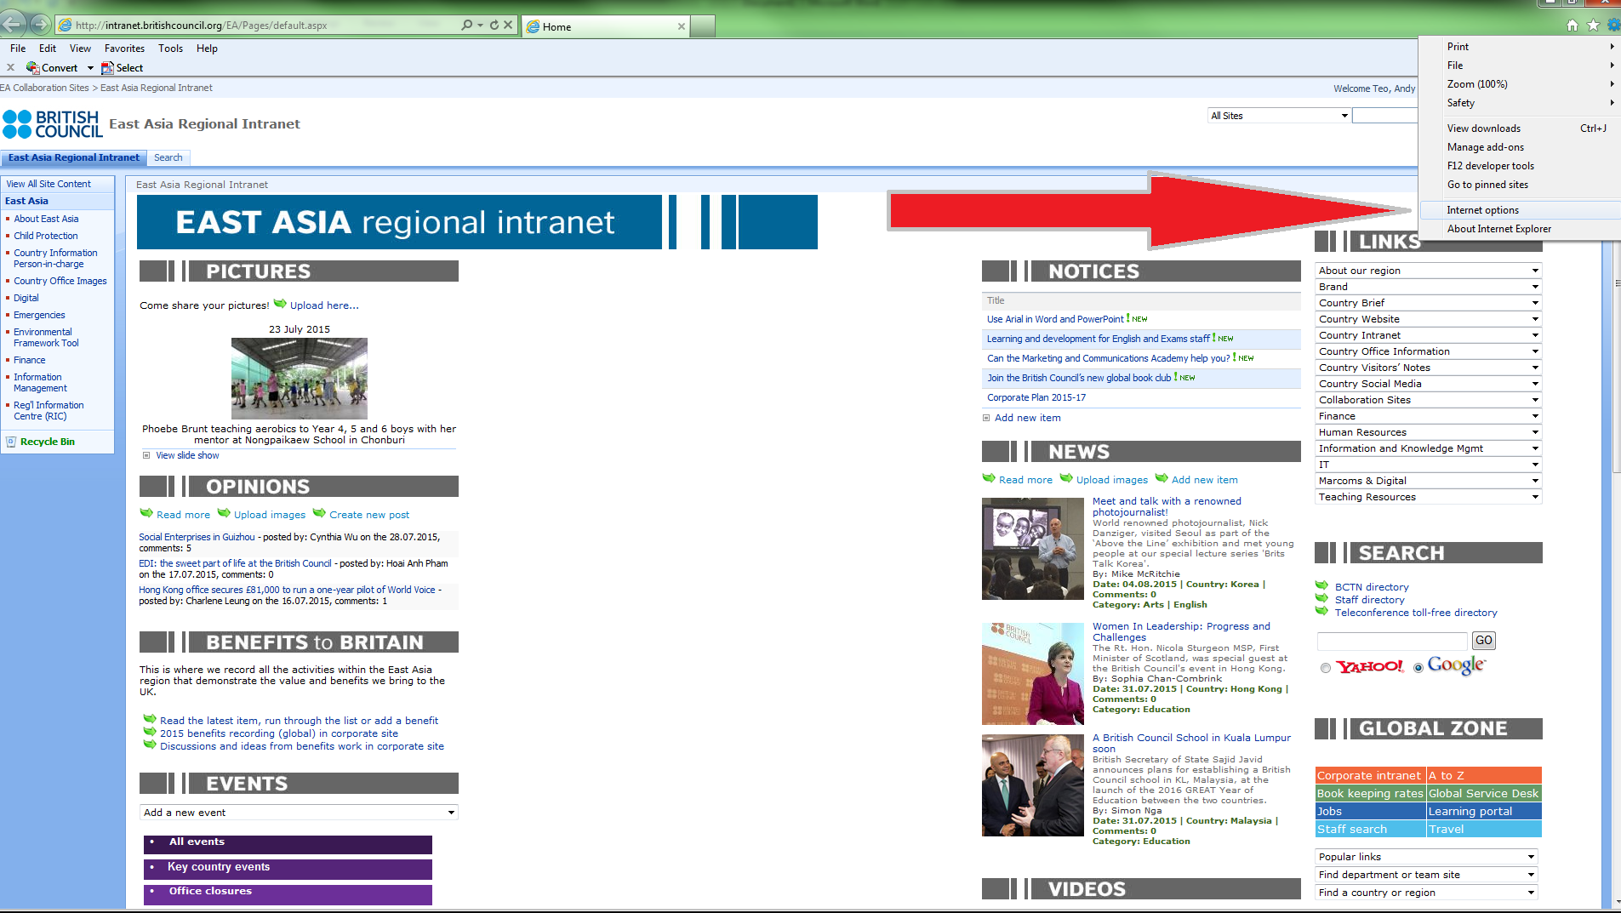

1. On the next pop up screen as shown below, make sure that the “Delete browsing history on exit” box is checked and then click on the “Delete” box (refer red arrows);

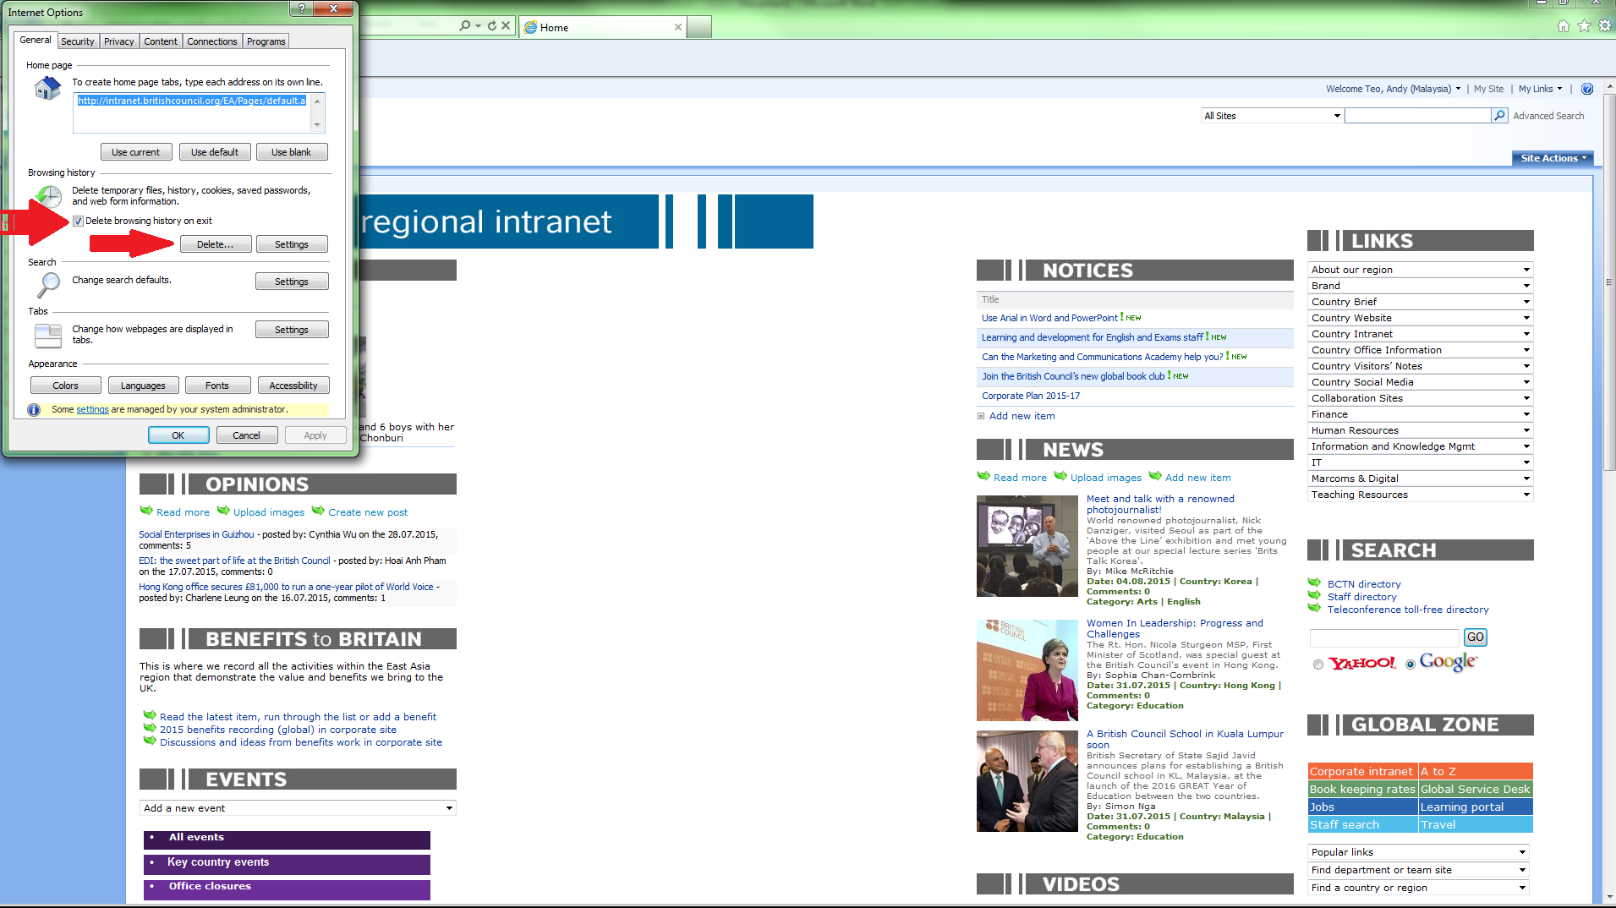

1. On the next pop up screen as shown below, make sure that all boxes are checked and then click on the “Delete” box;

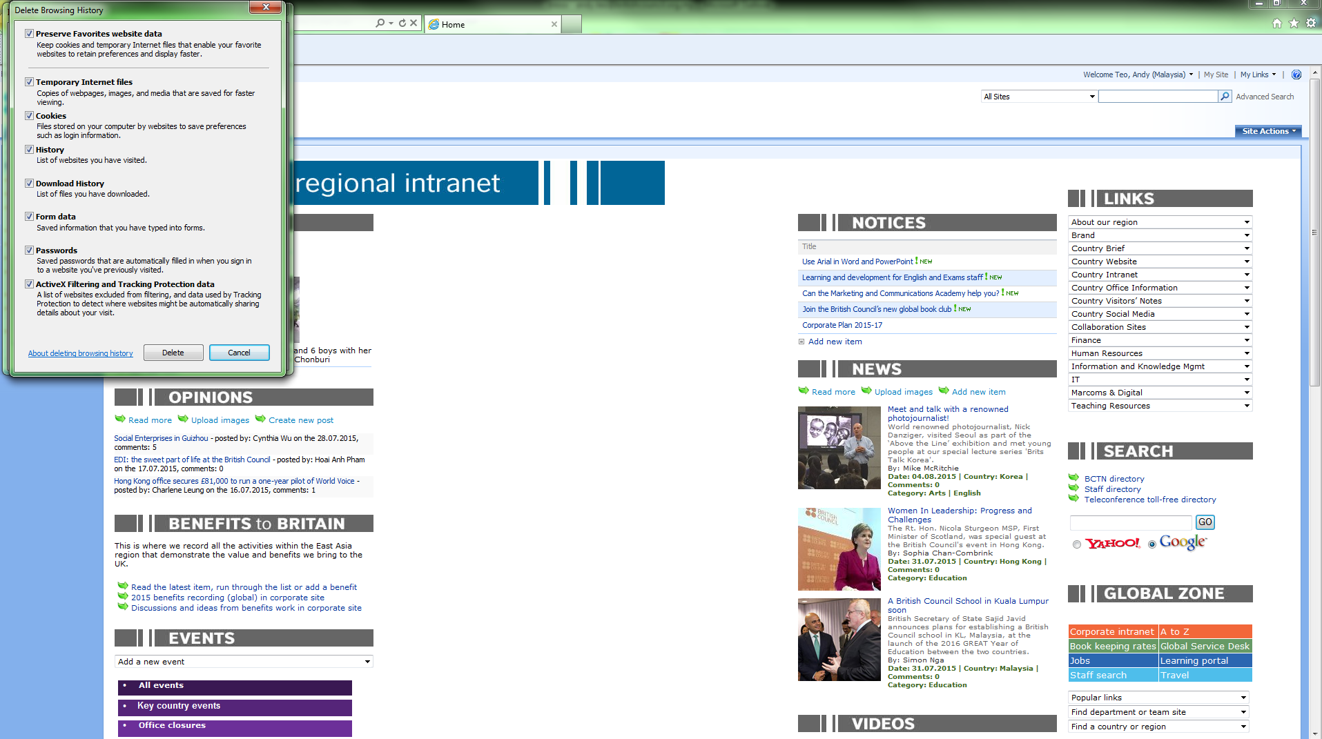

**Google Chrome**

1. The Google Chrome history can be cleared by going to the tools icon (3 horizontal lines) and selecting the internet options section as indicated below (refer red arrows)**;**

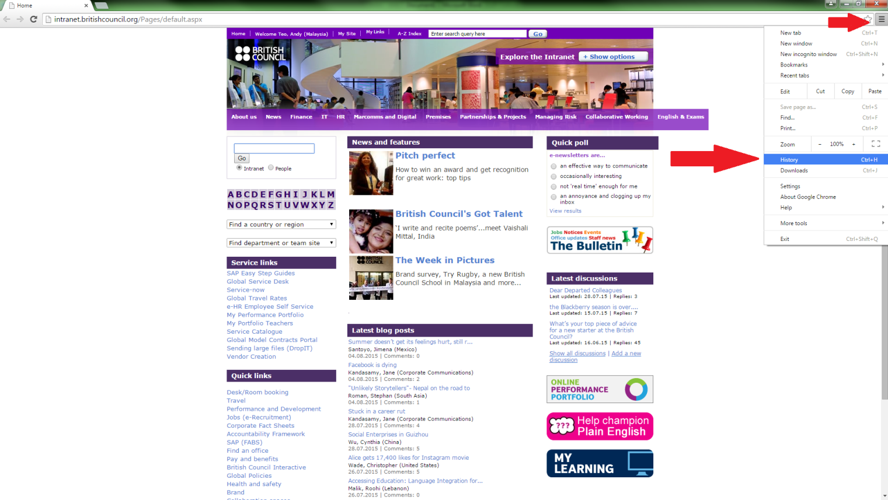

1. On the next pop up screen as shown below, click on the “Clear browsing data…” box (refer red arrow)**;**

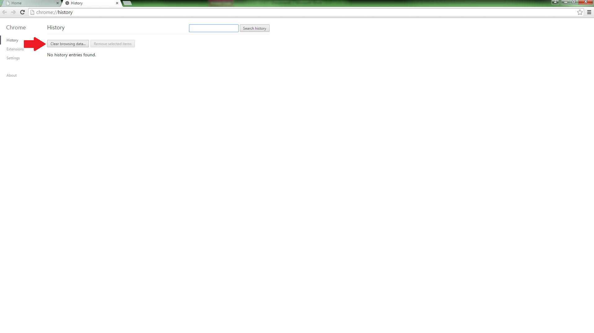

1. On the next pop up screen as shown below, make sure that the drop down box shows “the beginning of time” and all boxes are checked and then click on the “Clear browsing data” box (refer red arrows) ;

